Abstracts and Bios for NYCFE Fall Fraud Conference 2025
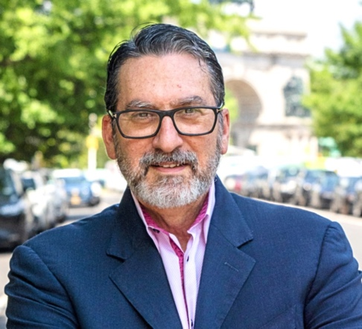
Alexander Stein, PhD
Title: Leveraging Psychodynamic Intelligence to Combat Fraud
Abstract:
Fraud, as the ACFE’s founder Joseph Wells once reminded us, “is committed by people, not
numbers.” It is a crime of relationships. The fraudster’s playbook exploits natural human
susceptibilities to psychological and emotional manipulation, deception, and betrayals of trust to foster victims’ unwitting cooperation against self-interest. Beyond commercial, transactional, and legal elements, every case is a thick stew of people’s motivations, decisions, wants, needs, fears, and blindspots, all influenced by personal histories and predispositions. In this presentation, I will shine a bright light on the complex psychodynamics at play in fraud matters, particularly in organizational contexts, and introduce psychologically sophisticated tools that counter-fraud professionals and business leaders can use to strengthen ethical culture, governance practices, and risk management to more effectively combat financial crime.

3 learning objectives:
After attending this session, participants should be able to:
- Recognize many of the ethical, psychological, and psychosocial dynamics at play in both individual and institutional fraud.
- Identify the organizational blind spots that typically constrain and undermine fraud
mitigation efforts and describe alternative, psycho-socially sophisticated methods to detect and mitigate fraud and other financial wrongdoing.
- Discuss psychodynamic intelligence analysis—decoding psychological fingerprints and shadow data (trace information about human thought and behavior)—to develop precision threat actor profiles and models of percolating intent and imminent malicious or lawless action.
Speaker Bio:

Dr Alexander Stein is the founder and Managing Principal of Dolus Advisors, a strategic
consultancy that leverages deep expertise in decision-making and the influences of power and psycho-social dynamics in organizational ecosystems to help senior leaders and boards resolve psychologically complex enterprise challenges. Drawing on his background as a clinical psychoanalyst, his approach combines sophisticated psychological insights with actionable strategies, uncovering blind spots, unrecognized decision-making patterns, and the cascading effects of overlooked human dynamics that affect organizational outcomes. Dolus Advisors’ core offerings include leadership advisory services, executive succession, governance effectiveness, organizational culture, ethics, and risk. Additional practice specializations cover the psychodynamics of fraud, corruption, and abuses of power; human-centered cybersecurity; and technologies that assume decision-making functions in human affairs. Dr Stein is a widely published and cited writer and thought leader, former regular contributor to Forbes, Fortune, CNN, and CBS Business News, frequent podcast and webinar guest, on-camera commentator, and keynote speaker and panelist. He is a Specialist Collaborator in the NIST Center for Human
Centered Cybersecurity, and the Editor-in-Chief of The CAI Report, a digital publication at the intersection of psychoanalysis and artificial intelligence.

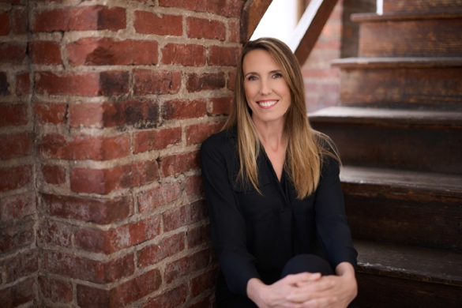

Linda Miller

Title: Using Gen AI to Fight Fraud

Abstract:
In the last two years fraud has been transformed by the proliferation of Gen AI tools that have lowered the barrier to entry for would-be fraudsters. Tools like voice spoofing and deepfake videos as well as exceptionally sophisticated phishing campaigns are all enabling the phenomenal growth of fraud. At the same time, these tools offer enormous promise in fighting fraud. This session will explore the ways fraud fighters can use Gen AI tools to detect and prevent fraud schemes.

Learning Objectives:

Identify the emerging trends in Gen AI-enabled fraud

Learn how to use Gen AI to combat fraud

Learn how to minimize the risks of using Gen AI tools

Linda Miller is a nationally recognized subject matter expert and
thought leader in fraud prevention and detection with over 17
years of experience. Ms. Miller has served in executive roles both in
government and the private sector, including as a Partner at
Guidehouse, Principal at Grant Thornton, and Deputy Executive
Director of the Pandemic Response Accountability Committee
(PRAC). In March 2023, she launched Audient Group, LLC, a
consulting firm specializing in antifraud solutions. She launched
TrackLight, Inc., an artificial-intelligence (AI) software company
specializing in antifraud solutions with co-founder Greg Loos in
June 2024 and she launched the Program Integrity Alliance in July
2024 with co-founder Gavin Ugale, which is a non-profit
committed to advancing independent research with a “do tank”
focus on generating actionable insights for policymakers and
practitioners to manage integrity risks.
Ms. Miller has unparalleled knowledge of U.S. federal government
fraud risk management leading practices. During her 10 years at
the Government Accountability Office (GAO), she led the
development of GAO’s Framework for Managing Fraud Risks in
Federal Programs, which provides guidance to help federal
managers in proactively preventing fraud. She also worked with
Congressional staffers to help draft the Fraud Reduction and Data
Analytics Act of 2015, superseded by the Payment Integrity and
Information Act. Ms. Miller also served on the task force that
developed the Committee of Sponsoring Organizations of the
Treadway Commission (COSO) Fraud Risk Management Guide,
which applies to private sector organizations. Prior to joining the
U.S. federal government, she competed in the 2000 Olympic Games
as a member of the U.S. National Rowing Team.


Lisa Meepummarin
Title
Rethinking E-Commerce Fraud: Legal, Compliance, and Risk Strategies in the Age of GenAI

Abstract
E-commerce fraud has entered a new era where generative AI, deepfakes, and dark-web data are fueling increasingly sophisticated attacks such as identity theft, account takeovers, scams, and chargeback abuse. These developments create not only financial and operational risks but also escalating legal and regulatory exposure. Regulators and courts are scrutinizing whether companies are taking reasonable measures to protect customers while maintaining trust and a seamless digital experience.
This session will explore how fraud manifests across the customer lifecycle from sign-up to payment, returns, and disputes, and what legal and compliance leaders need to know about regulatory expectations in the U.S. and abroad. Attendees will gain practical insights on aligning fraud policies with evolving laws, setting fraud tolerance thresholds, and creating governance structures that balance fraud prevention, customer experience, and defensibility in investigations or enforcement actions.

Learning Objectives
- Recognize the most pressing e-commerce fraud schemes (for example account takeover, synthetic identity, BNPL fraud, and scams) and the legal and regulatory risks they create.
- Understand the regulatory frameworks shaping fraud response, including consumer protection, AML/KYC, AI bias, and data privacy requirements.
- Apply actionable strategies for defining fraud tolerance thresholds, preparing defensible incident response playbooks, and building governance models that enable both compliance and business growth.

Speaker Bio (Lisa Meepummarin)
Lisa is a director with PwC’s Cyber, Risk and Regulatory Managed Services practice. She has more than 19 years of experience advising clients on risk and compliance matters and helping clients mitigate customer and payment risks while reducing impact to customer experience by deploying innovative solutions, including identity verification, authentication, and fraud detection analytics. She has significant experience leading fraud risk and control assessments and control transformations for clients across industries including Financial Services, eCommerce, Retail, FinTech, Telecommunications and others.

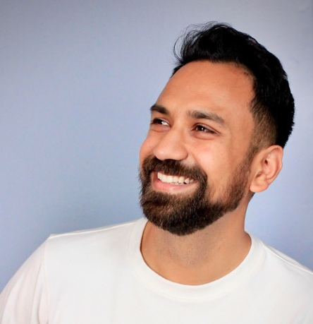
Arjun Bisen
Title:
AI Agents in Financial Investigations: Automating Due Diligence and Tracking Fraud using OSINT
Abstract:
As fraud and financial crime operations evolve, so must our methods of investigation and intelligence gathering. This session explores how AI agents are transforming investigative workflows, automating due diligence, and continuously monitoring emerging risks across both open and closed networks. We’ll walk through real-world applications of AI-driven intelligence systems, including how enterprises are identifying fraud patterns faster and adapting to shifting threat landscapes.
We’ll also examine new digital ecosystems beyond traditional social and messaging platforms, exploring where fraudsters are moving their operations and what that means for compliance, fraud prevention, and investigative teams.
Learning Objectives:
- Understand how AI agents can automate and augment investigative and due diligence processes.
- Learn how enterprises are leveraging AI for continuous intelligence monitoring and fraud detection.
- Identify emerging platforms and patterns where fraud operations are relocating, and how to stay ahead of these shifts.
Bio:
Arjun Bisen is a Cofounder of Overwatch Data, an AI-powered cyber and fraud threat intelligence platform that builds AI agents to assist risk, compliance, and fraud teams across major financial institutions. Previously, Arjun led digital risk mitigation efforts at Stripe, Google, and within the Australian Government. As a former Fulbright Scholar, he speaks regularly on the future of AI-driven investigations and the evolving intersection of fraud, compliance, and data.


Balki Aydin Osmanoglu

Title:
Inside Scam Centers: Human Trafficking, Forced Labor, and Global Fraud Networks

Bio:

Balki Aydin Osmanoglu is a Senior Financial Crime Compliance Advisor at The Mekong Club, a Hong Kong–based organization that partners with the private sector to combat modern slavery. She has over 14 years of management consulting experience in the financial services industry, specializing in AML compliance, regulatory risk management, and cryptocurrency compliance solutions.

Throughout her career, Balki has developed financial crime compliance programs, supported regulatory examinations and overseen BSA/AML operations. She is a subject matter expert on anti-human trafficking and the fight against modern slavery and holds the Certified Anti-Money Laundering Specialist (CAMS) and Certified Fraud Examiner (CFE) credentials.

Abstract:

Scam centers in Southeast Asia have rapidly evolved into a multibillion-dollar criminal industry built on human trafficking, forced labor, and transnational fraud. Thousands of individuals are lured into scam centers with false job offers, trafficked across borders, and forced to run online romance and investment scams that defraud victims worldwide, with a growing impact on Americans.

This session will examine how these centers are structured and operate: how they recruit and control victims, execute complex fraud schemes, and launder illicit proceeds across multiple sectors and jurisdictions. It will also outline practical ways to identify red flags, detect suspicious activity, and strengthen safeguards to prevent financial institutions from being misused to facilitate financial crime.

Learning Objectives:

After attending this session, participants will be able to:

1. Understand how scam centers operate in Southeast Asia and their links to human trafficking, forced labor and money laundering.
2. Identify the methods used by scam centers to recruit and control victims, execute online romance and investment scams, and launder illicit proceeds across multiple sectors and jurisdictions.
3. Learn practical strategies to recognize red flags, detect suspicious activities, and implement safeguards to prevent legitimate infrastructure from being exploited for financial crime.

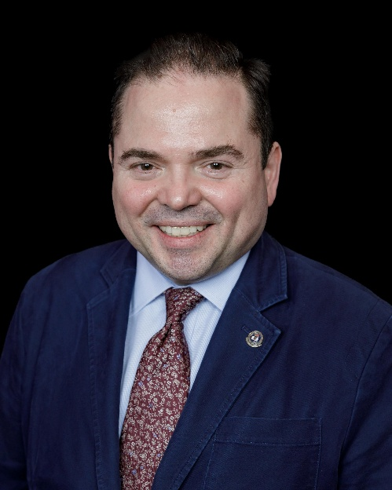

Speaker: Ozan Gurel, President – NYCFE, Inc., Founder – Bard Dynamic, LLC
Title: Emerging Ethics Issues for Certified Fraud Examiners
Abstract:
This session will involve an interactive discussion of many of the emerging ethics issues challenging Certified Fraud Examiners. It will include a presentation of various points about data privacy, artificial intelligence, and conflicts of interest, among other issues, with active participation of the attendees.
Learning objectives include:
- Increasing awareness of specific ethical challenges for CFEs
- Promoting the ability to articulate personal perspectives on ethics issues
- Reinforcing longstanding commitments to professional standards

Bio:

Ozan Gurel has been President of the New York Chapter of the Association of Certified Fraud Examiners since January 2024, after having served as Vice President for four years starting in 2020. He has been a Certified Fraud Examiner since 2015 and founded Bard Dynamic, LLC in 2017. His professional experience in anti-fraud work began with fraud detection in the insurance industry.

